Prtf 2 Danish Monarchs
Author Name(s): Christian Andersen
Github URL for your rmarkdown/html files: https://github.com/Digital-Methods-HASS/au725102_Andersen_Christian/tree/main
Answer these questions by listing both the chunk of code you used and then the response

What function did you use to load your dataset in R as a tibble? What do you see when you run head() on your ‘kings’ digital object? How do you confirm your kings’ object in R is a tibble?

1. What function did you use to load your dataset in R as a tibble?
Jeg bruger read_csv() til at læse csv filen.
Code: kings <- read_csv("data/Kongerækken.csv")
2. What do you see when you run head() on your ‘kings’ digital object?
I see a 6x6 tibble 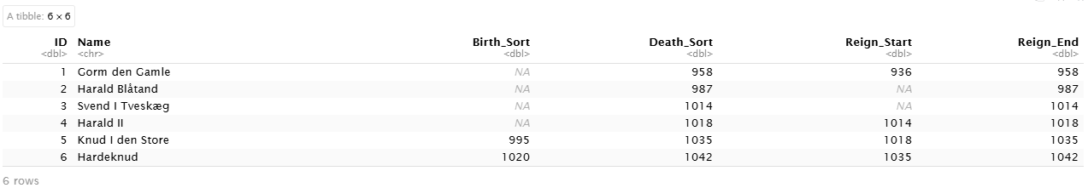
Code: heads(kings)
3. How do you confirm your kings’ object in R is a tibble?
Det gør jeg med class(kings).
Paste here a screenshot of the Console after running head(kings) or glimpse(kings):
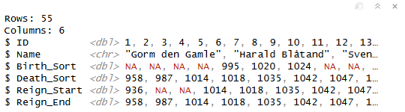

What is the average age of reign among your monarchs and how many rulers have exceeded it?
Jeg vil gerne udregne gennemsnittet
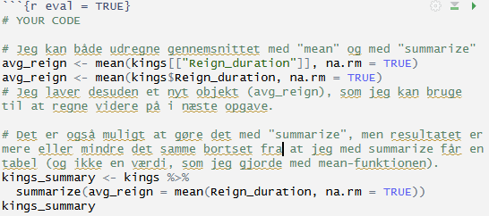
Derefter finder jeg antallet af regenter, der har regeret mere end gennemsnittet.
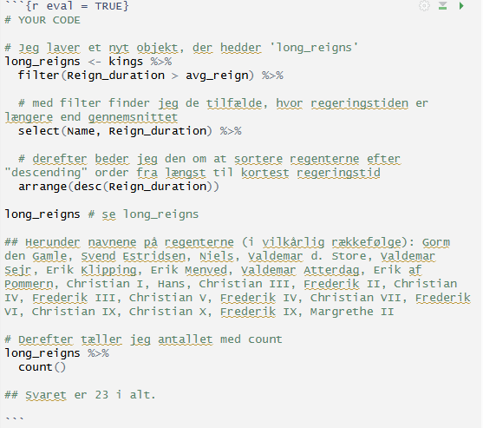
Result/Answer: den gennemsnitlige regeringstid er 20,3 år og 23 regenter har regeret mere end gennemsnittet.

How many days did the three longest-ruling monarchs rule?
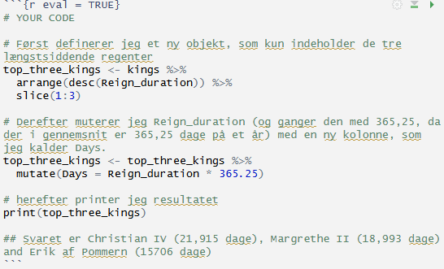
Result/Answer: Christian IV (21,915 dage), Margrethe II (18,993 dage) og Erik af Pommern (15,706 dage).

Challenge: Plot the duration of reign in time and briefly answer “What is the long-term trend in the duration of reign among monarchs?”
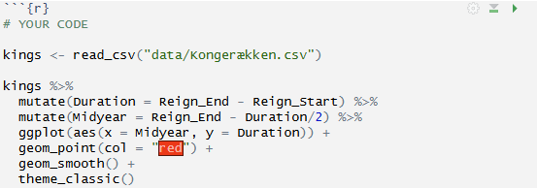

Visual
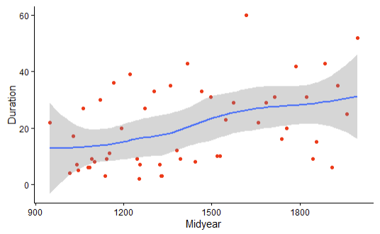
Answer: den generelle trend er, at regeringstiden er stødt stigende (og accelerer specielt i 14- og 1500-tallet).

